21.31: a) Passing between the charged plates the electron feels a force upward, and just misses the top plate. The distance it travels in the y-direction is 0.005 m. Time of flight 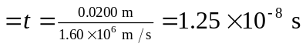 and initial y-velocity is zero. Now, But also
b) Since the proton is more massive, it will accelerate less, and NOT hit the plates. To find the vertical displacement when it exits the plates, we use the kinematic equations again:
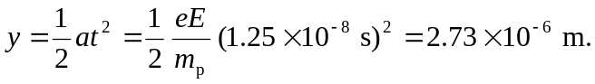
c) As mention in b), the proton will not hit one of the plates because although the electric force felt by the proton is the same as the electron felt, a smaller acceleration results for the more massive proton.
d) The acceleration produced by the electric force is much greater than g; it is reasonable to ignore gravity.

